CUSTOMER QUOTE ENTRY VIA EIP

Note: All information must be entered in a consistent manner amongst the different people. See figure below for inconsistencies that make finding information in the system difficult.

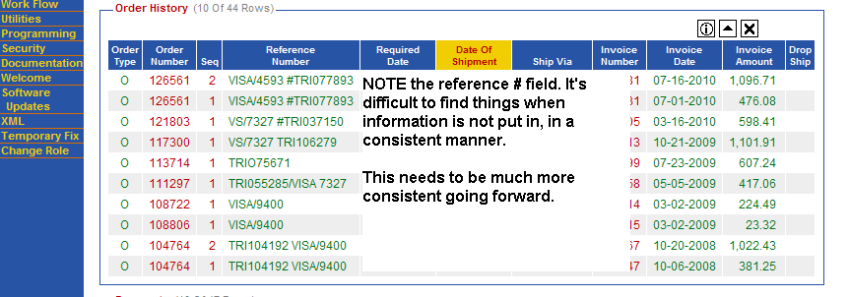

VIEW QUOTES:
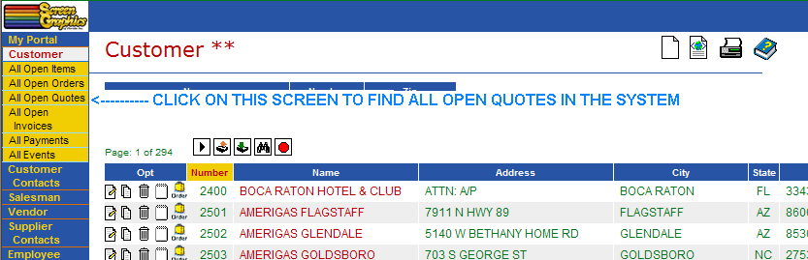

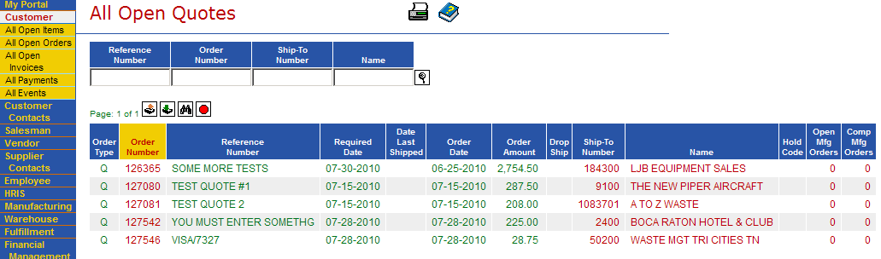

QUOTE ENTRY
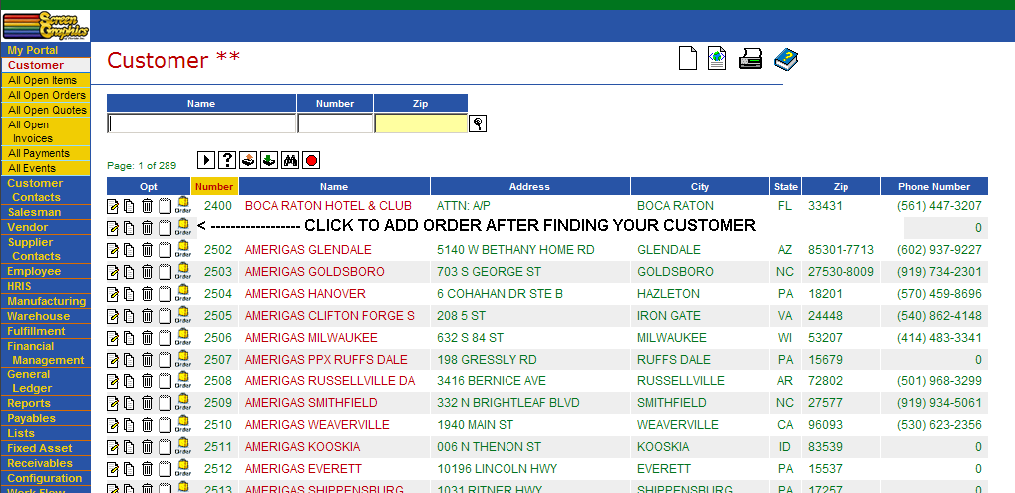
OR you may also enter from the screen below
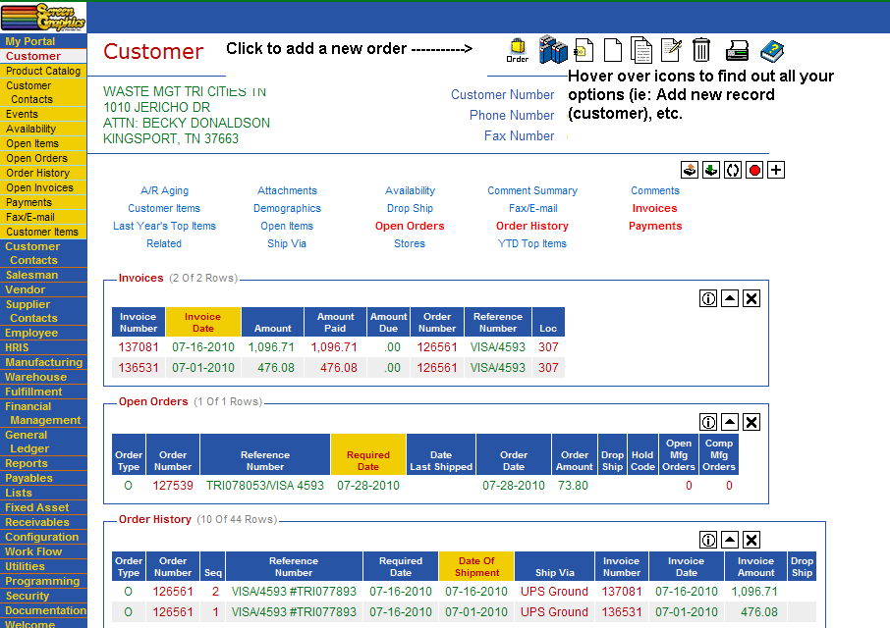

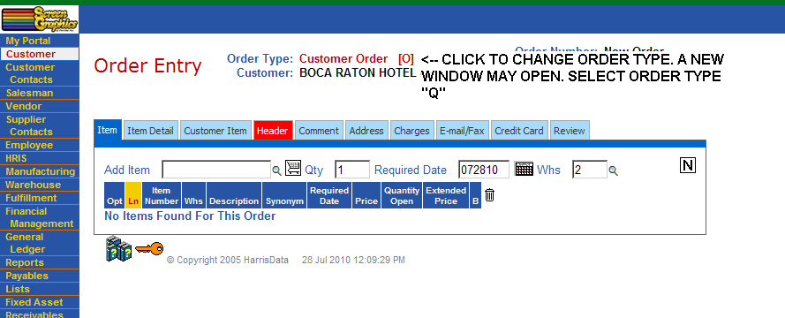

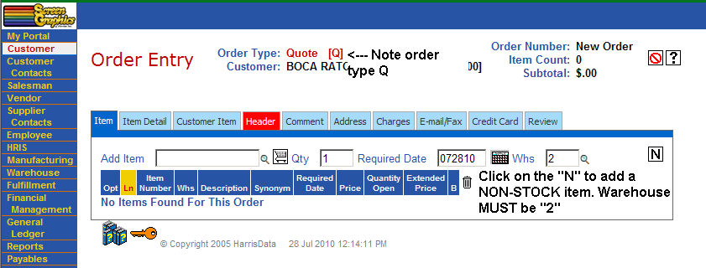

Be sure to review each of the light blue tabs below before finishing the quote/order.
Be sure to click the CHECK inside each tab to save your work BEFORE going to the next tab.
